Mary M. (Booher) Carter
December 14, 1853 – November 21, 1919

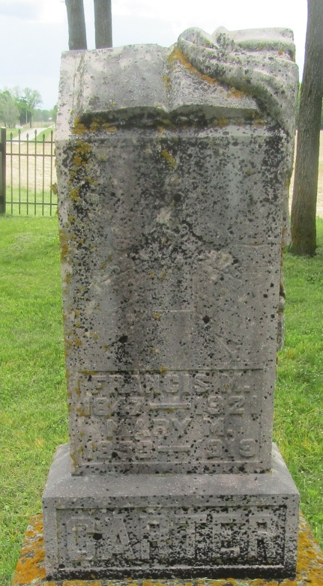
Mary M. Carter
in the Indiana, U.S., Death Certificates, 1899-2011
Name: Mary M. Carter
[Mary M. Booher]
Gender: Female
Race: White
Age: 65
Marital status: Married
Birth Date: 14 Dec 1853
Birth Place: Ohio
Death Date: 21 Nov 1919
Death Place: Wells, Indiana, USA
Father: John Booher
Mother: Phoebe C. Blazer
Spouse: Frank P. Carter
Informant; Frank P. Carter; Jeff., Indiana
Burial: November 24, 1919; Wright Cemetery

