Lorenso Brotherton
1881 – March 13, 1900

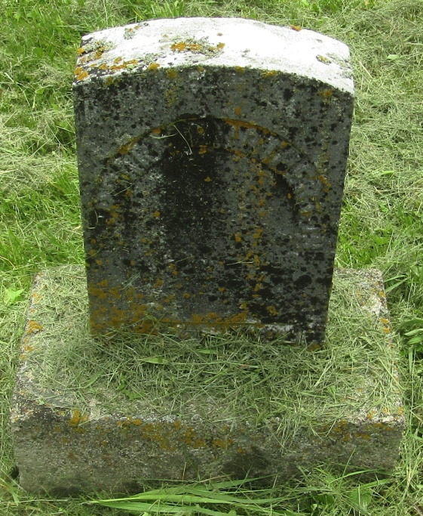

Lorenso Brotherton
in the Indiana, U.S., Death Certificates, 1899-2011
Name: Lorenso Brotherton
Gender: Male
Race: White
Age: 19
Marital status: Single
Birth Date: abt 1881
Birth Place: Wells Co Ind
Death Date: 13 Mar 1900
Death Place: Montpelier, Blackford, Indiana, USA
Father: Geo Brotherton
Mother: Barbery McCullser
Informant: Geo. Brotherton; Montpelier, Indiana
Burial: March 14, 1900; Wright Cemetery

