Allen Hyet Gustin
April 26, 1833 – August 3, 1903
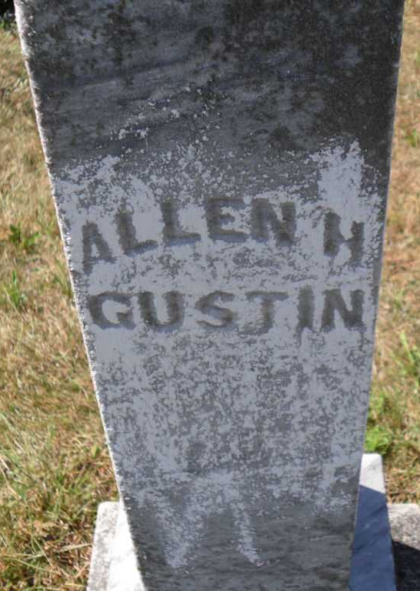
DIED AT KEYSTONE
Monday evening at Keystone occurred the death of Allen Gustin, one of the oldest citizens of the place. Mr. Gustin had reached his seventy-fifth birthday. For some time he has been a sufferer from asthma and it was this dread malady that caused his death. He leaves to mourn his loss a wife and five children.

Bluffton Banner, Wells County, Indiana
August 5, 1903
*****
Allen H Gaster
in the Indiana, Death Certificates, 1899-2011
Name: Allen H Gustin
Gender: Male; Race: White; Age: 77; Marital status: Married
Birth Date: 26 Apr 1833; Birth Place: Madison Co Ind
Death Date: 3 Aug 1903; Death Place: Keystone, Wells, Indiana , USA
Father: Alkoy Gustin; Spouse: Sara J.
Informant: Jesse C. Gustin; Keystone, Ind.
Burial: Aug. 6, 1903; Stahl Cem.

