Delila (Blair) Grove
March 18, 1869 – May 21, 1932

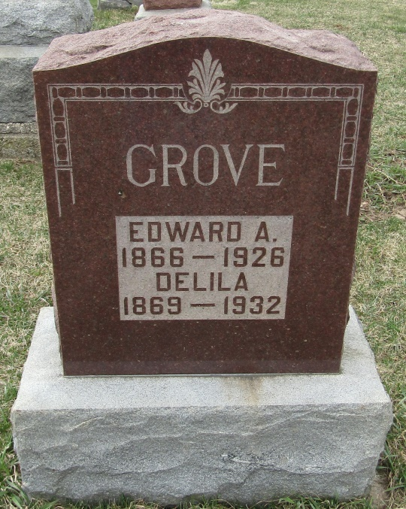
Delila Grone
in the Indiana, Death Certificates, 1899-2011
Name: Delila Grove
[Delila Blain]
Gender: Female
Race: White
Age: 63
Marital status: Widow
Birth Date: 18 Mar 1869
Birth Place: Wells Co., Ind.
Death Date: 21 May 1932
Death Place: Poneto, Wells, Indiana , USA
Father: Robert Blair
Mother: Katherine Gehrett
Spouse: Edward Grove
Informant: John Grove; Poneto, Ind.
Burial: May 24, 1932; Stahl Cem.

