Angeline H. (Smith) Grove
March 29, 1844 – January 15, 1933

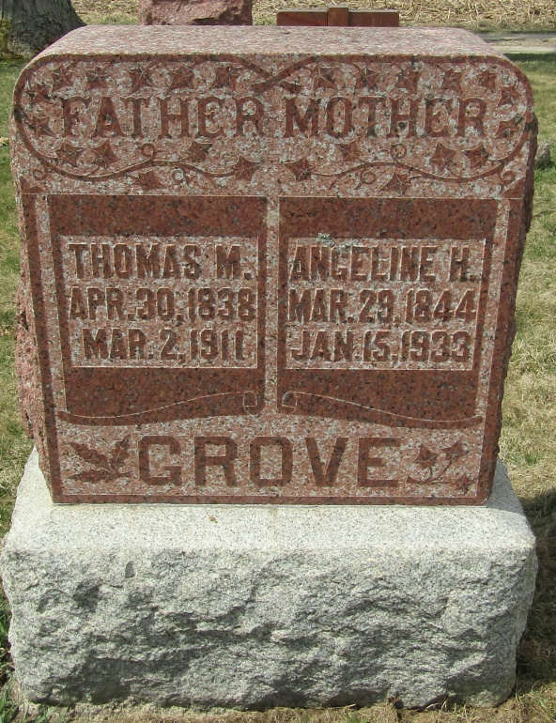
Angeline H Grove
in the Indiana, Death Certificates, 1899-2011
Name: Angeline H Grove
[Angeline H Smith]
Gender: Female
Race: White
Age: 88
Marital status: Widow
Birth Date: 29 Mar 1844
Birth Place: Wells Co Indiana
Death Date: 15 Jan 1933
Death Place: Harrison, Wells, Indiana , USA
Father: Robt Y Smith
Mother: Angeline Howe
Spouse: Thomas M Grove
Informant: Arnold Grove; Poneto, Ind.
Burial: Jan. 18, 1933; Stahl Cem.

