Mary Helen Graham
February 6, 1926 – February 7, 1926
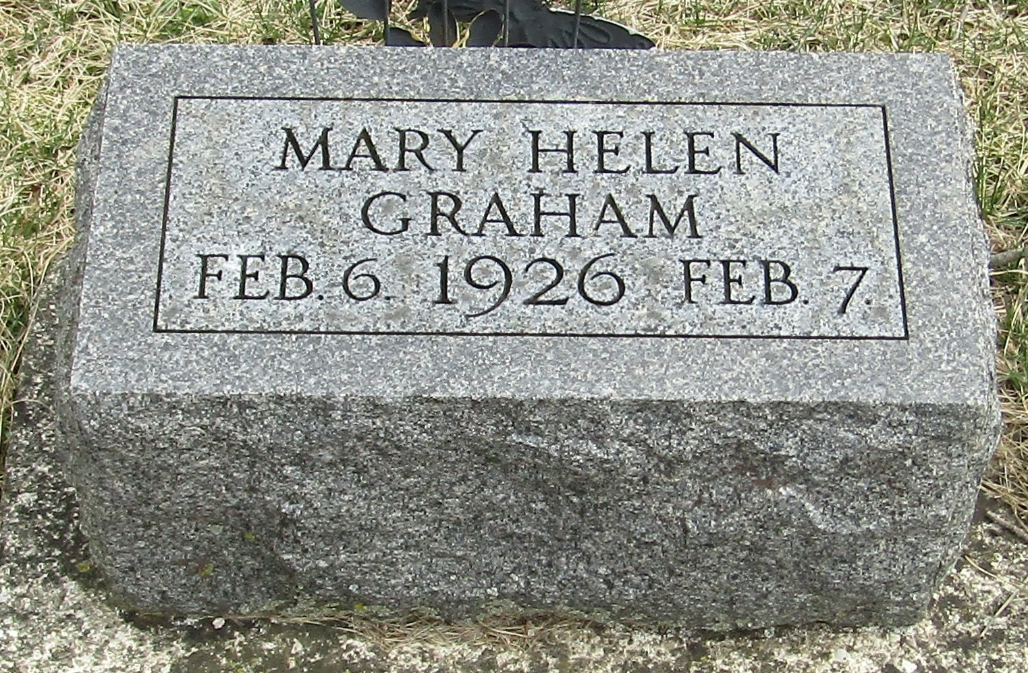
Mary Helen Graham
in the Indiana, Death Certificates, 1899-2011
Name: Mary Helen Graham
Gender: Female
Race: White
Age: 1 day
Birth Date: 6 Feb 1926
Birth Place: Adams Co Ind
Death Date: 7 Feb 1926; premature birth
Death Place: Linn Grove, Adams, Indiana , USA
Father: Theodore Graham
Mother: Mary Taylor
Burial: Feb. 8, 1926; Stahl Cem.

