Helen C. (Harris) Gordon
June 13, 1913 – November 6, 1996
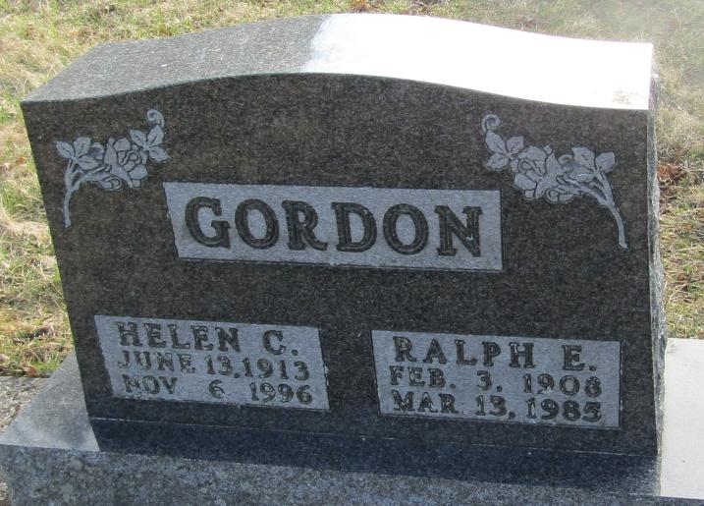
Helen C Gordon
in the Indiana, Death Certificates, 1899-2011
Name: Helen C Gordon
[Helen C Harris]
Gender: Female
Race: Caucasian (White)
Age: 83
Marital status: Widowed
Birth Date: 13 Jun 1913
Birth Place: Wells County, In
Death Date: 6 Nov 1996
Death Place: Fort Wayne, Allen, Indiana , USA
Father: Guy Harris
Mother: Retta McGeath
Informant: Diane Guiler; daughter; Fort Wayne, Ind.
Burial: Nov. 9, 1996; Stahl Cem., Bluffton, Ind.

