Bessie (Burgess) Gerard
November 11, 1900 – June 7, 1973
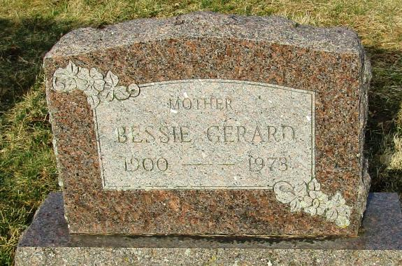
Bessie Gerard
in the Indiana, Death Certificates, 1899-2011
Name: Bessie Gerard
[Bessie Burgess]
Gender: Female
Race: White
Age: 72
Marital status: Widowed
Birth Date: 11 Nov 1900
Birth Place: Indiana
Death Date: 7 Jun 1973
Death Place: Fort Wayne, Allen, Indiana , USA
Father: Andrew Burgess
Mother: Emma Kizer
Informant: Mrs. Richard (Rena) McGee; daughter; Ft. Wayne, Ind.
Burial: June 9, 1973; Stahl Cem., Reiffsburg, Ind.

