Hugh L. Gehrett
May 7, 1883 – March 17, 1894
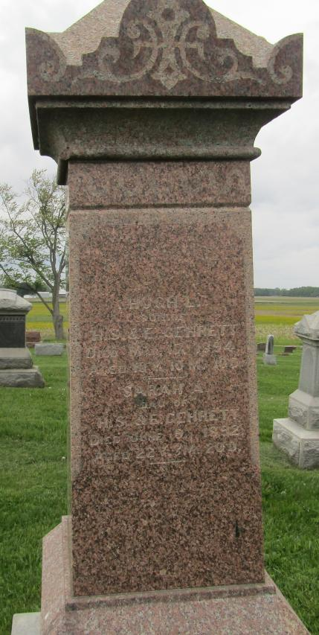
A SORROWING HOME
The home of Henry S. Gehrett and wife is wrapped in sorrow on account of the death of their son Hugh. He would have been eleven years old May 7. Two or three weeks ago he was attacked with measles which went to his throat and lungs and caused his death. Everything that love and skill could do to save the boy was done, but without avail. He grew constantly worse and death relieved his suffering Saturday night.
His funeral occurred at the residence on East Market Street Monday at ten o'clock, conducted by Rev. W. W. Hicks. The remains were taken to the Stahl Cemetery for interment.
Hugh was a bright and amiable little fellow, a favorite with his teachers and school mates, who greatly miss him. He was the light of the home from which he was taken, and his parents feel the keen anguish of separation from him. They have the cordial sympathy of a large circle of friends and neighbors.

Bluffton Banner, Wells County, Indiana
Wednesday, March 21, 1894

