George Gehrett
February 28, 1861 – June 9, 1927
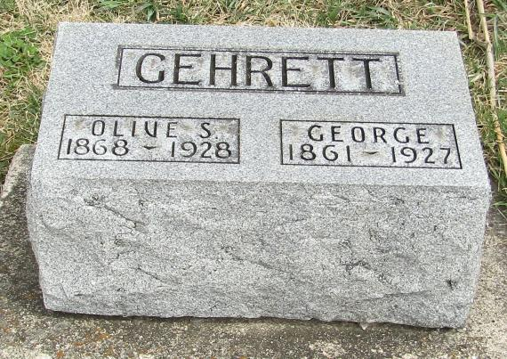
George Gelnett
in the Indiana, Death Certificates, 1899-2011
Name: George Gehrett
Gender: Male
Race: White
Age: 66
Marital status: Married
Birth Date: 28 Feb 1861
Birth Place: Wells Co, Ind
Death Date: 9 Jun 1927
Death Place: Bluffton, Wells, Indiana , USA
Father: Samuel Gehrett
Mother: Sarah King
Spouse: Ollie Lee
Informant: Ollie Gehrett; Bluffton, Ind.
Burial: June 11 1927; Stahl Cem.,

