John Henry Franklin
June 26, 1840 – January 9, 1921

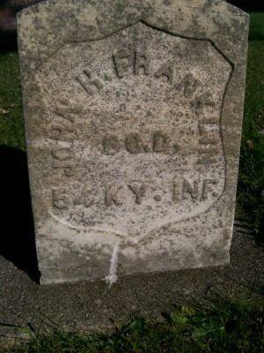
Photo by Scott Shoup

Funeral of Veteran
Body of John Henry Franklin Will Be Buried at Petroleum

The funeral of the late John Henry Franklin was conducted at his late home at 2127 North E. Street this afternoon at 2:30 o’clock and attended by many friends.
This good citizen and good soldier, whose war record was something of which he was very proud, is survived by the widow and three children, John W., Mary Ann and Jessie, all residing in this city.
The body will be taken over the traction line tomorrow morning to Petroleum, Wells County, where the burial will take place.

No source listed

