Harry G. Foreman
June 12, 1926 – July 15, 1994

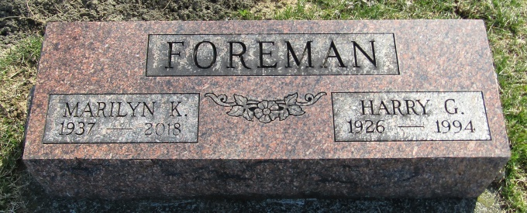

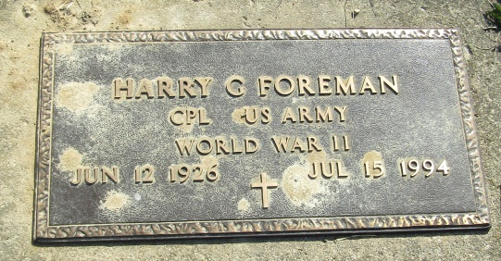

Indiana, Death Certificates, 1899-2011
Name: Harry G Foreman
Gender: Male; Race: White; Age: 68; Marital status: Married
Birth Date: 12 Jun 1926; Birth Place: Peru, Indiana
Death Date: 15 Jul 1994; Death Place: Fort Wayne, Allen, Indiana
Father: Marion E Foreman; Mother: Lela M Redman
Spouse: Marilyn K Onweller
Informant: VA hospital records; Fort Wayne, Ind.
Burial: July 18, 1994; Stahl Cem., Petroleum, Ind.

