Willard Richard Ford
February 8, 1887 – July 13, 1962
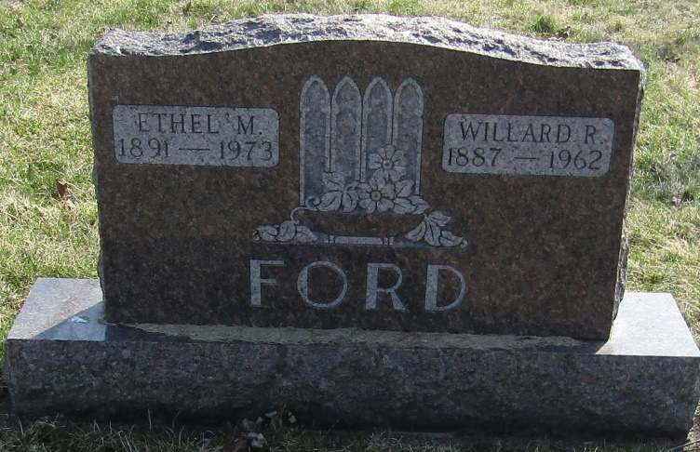
Willard Richard Ford
in the Indiana, Death Certificates, 1899-2011
Name: Willard Richard Ford
Gender: Male
Race: White
Age: 75
Marital status: Married
Birth Date: 8 Feb 1887
Birth Place: Randolph Co, Indiana
Death Date: 13 Jul 1962
Death Place: Logansport, Cass, Indiana , USA
Father: Wilson Ford
Mother: Mary E French
Informant: Logansport State Hospital; Logansport, Ind.
Burial: July 16, 1962; Laketon Cem., Wabash Co, Ind. (sic)

