Larry D. Ford
October 4, 1945 – October 10, 2014

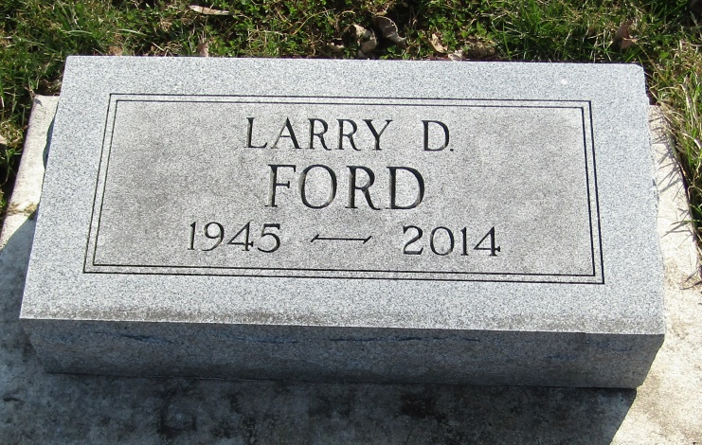

Larry D. Ford, 69, formerly of Churubusco and Kendallville, passed away at 7:45 p. m. on Friday, October 10, 2014 at North Ridge Village Nursing Home in Albion. He had been a patient there since 2009.
Mr. Ford was born in Wabash County on October 4, 1945, a son of Henry H. and Helen Louise (Cleek) Ford, and graduated from Central High School in Fort Wayne in 1963. He retired in 2006 from Flint & Walling, Inc. in Kendallville after 30 years.
Surviving are his sister-in-law Linda (Warren, Jr.) Deck of Churubusco; a step-niece April Miller of New Haven;a step-nephew Donald A. Boseker of Columbia City; and his aunt Sue Baker of Richmond.
In addition to his parents, he was preceded in death by a brother Gerald L. “Jerry” Ford on December 30, 2007.
Funeral services will be held at 1 p. m. on Monday, October 13, 2014, at the Sheets & Childs Funeral Home in Churubusco with Father Danney Pinto, pastor of St. John Bosco Catholic Church, officiating.
Friends may call at the funeral home one hour prior to the service.
Burial will be in the Stahl Cemetery, Bluffton.

Sheets & Childs Funeral Home, Whitley County, IN
9/14/2019

