George Fink
August 3, 1862 – June 12, 1957
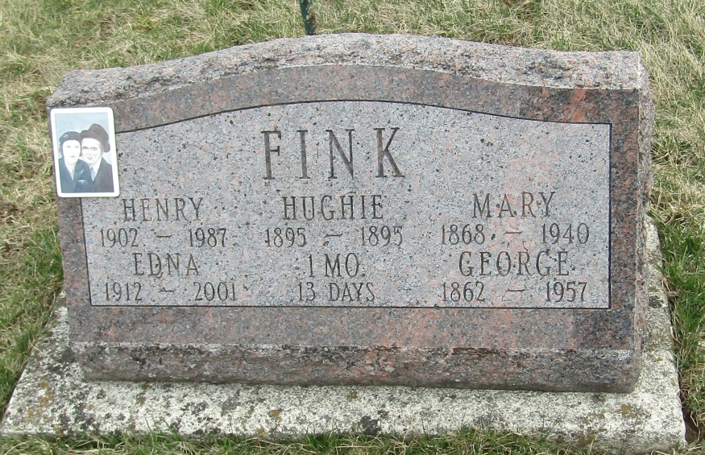
George Fink
in the Indiana, Death Certificates, 1899-2011
Name: George Fink
Gender: Male
Race: White
Age: 94 years, 10 months, 9 days
Marital status: Widowed
Birth Date: 3 Aug 1852 [sic]
Birth Place: Jay County, Indiana
Death Date: 12 Jun 1957
Death Place: Big Lake, Noble, Indiana , USA
Father: (Unknown) Fink (dec'd)
Mother: Susan Umphenier (dec'd)
Informant: Henry W. Fink; son; Columbia City, Ind.
Burial: June 15, 1957; The Stahl Cem., Wells Co., Ind.

