Edna Evelyn (Bay) Fink
August 3, 1912 – May 24, 2001
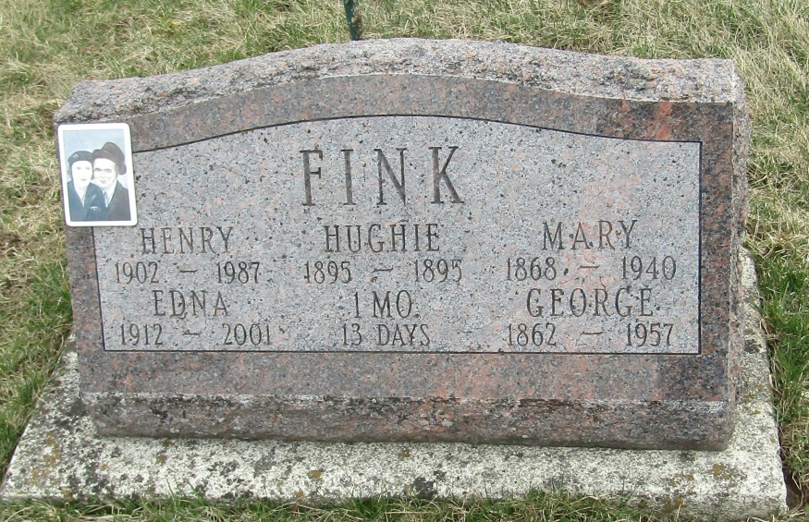
Edna E Fink
in the Indiana, Death Certificates, 1899-2011
Name: Edna E Fink
[Edna E Bay]
Gender: Female
Race: White
Age: 88
Marital status: Widowed
Birth Date: 3 Aug 1912
Birth Place: Wells County, Ind
Death Date: 24 May 2001
Death Place: Fort Wayne, Allen, Indiana , USA
Father: Edward Bay
Mother: Stella Moore
Informant: Janice Perry; daughter; Huntington, Ind.
Burial: May 29, 2001; Stahl Cem., Wells Co., Ind.

