John M. Fellows
June 16, 1915 – July 6, 1968
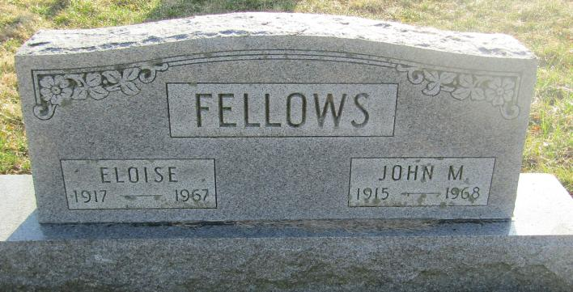
John Fellows
in the U.S., Social Security Death Index, 1935-2014
Name: John Fellows
SSN: xxx
Last Residence:
48161 Monroe, Monroe, Michigan, USA
Born: 16 Jun 1915
Died: Jul 1968
State (Year) SSN issued: Indiana (Before 1951)

