Carrie May (Kimmel) Farlow
June 5, 1905 – July 31, 1978
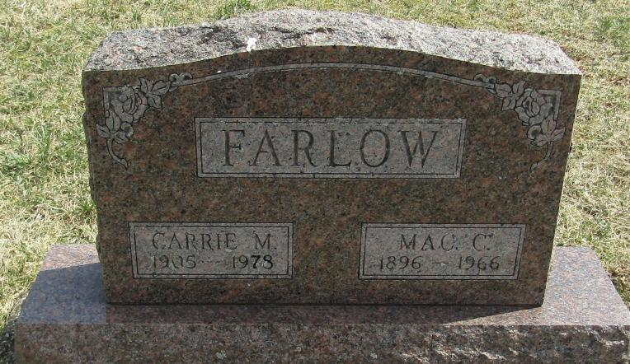
Carrie M. Farlow
in the Indiana, Death Certificates, 1899-2011
Name: Carrie M. Farlow
[Carrie M. Kimmel]
Gender: Female
Race: White
Age: 73
Marital status: Widowed
Birth Date: 5 Jun 1905
Birth Place: Indiana
Death Date: 31 Jul 1978
Death Place: Bluffton, Wells, Indiana , USA
Father: Levi Kimmel
Mother: Mary Tewell
Informant: Mary Smith; Poneto, Ind.
Burial: Aug. 2, 1978; Stahl Cem., Wells Co., Ind.

