Jacob Archer Elston
July 11, 1868 – November 4, 1935

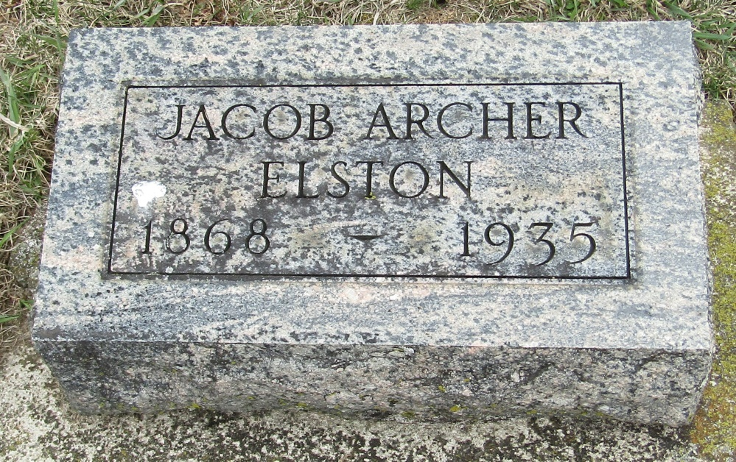

Jacob Archer Elston
in the Indiana, Death Certificates, 1899-2011
Name: Jacob Archer Elston
Gender: Male
Race: White
Age: 67
Marital status: Single
Birth Date: 11 Jul 1868
Birth Place: Wells Co, Indiana
Death Date: 4 Nov 1935; suicide
Death Place: Harrison, Wells, Indiana , USA
Father: H B Elston
Mother: Elizabeth Stahl
Informant: Oliver Elston; Bluffton, Ind.
Burial: Nov. 6, 1935; Stahl Cem.

