Elmira B. (King) Elston
April 4, 1861 – October 20, 1920

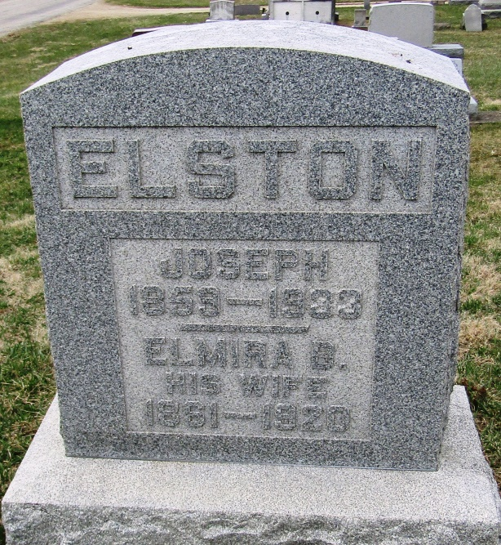

Elvira Elston
in the Indiana, Death Certificates, 1899-2011
Name: Elmira Elston
[Elmira King]
Gender: Female
Race: White
Age: 59
Marital status: Married
Birth Date: 4 Apr 1861
Birth Place: Indiana
Death Date: 20 Oct 1920
Death Place: Petrolium, Wells, Indiana , USA
Father: Adam King
Mother: Elizabeth Bollander
Spouse: Joseph Elston
Informant: Family; Bluffton, Ind.
Burial: Oct. 22, 1920; Stahl Cem.

