Elizabeth (Stahl) Elston
May 20, 1827 – April 12, 1910

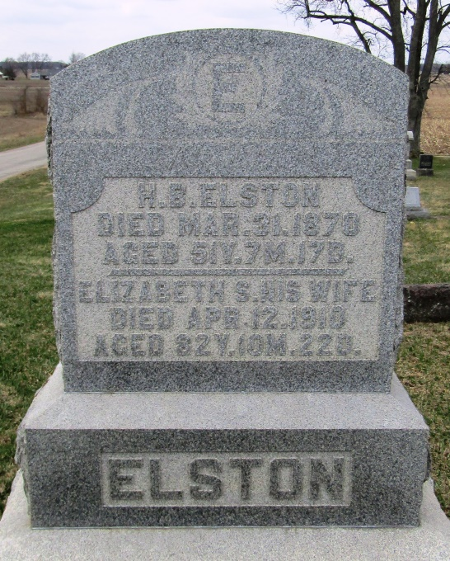

Elizabeth Stahl Elston
in the Indiana, Death Certificates, 1899-2011
Name: Elizabeth Stahl Elston
[Elizabeth Stahl Stahl]
Gender: Female
Race: White
Age: 82
Marital status: Widow
Birth Date: 20 May 1827
Birth Place: Penn
Death Date: 12 Apr 1910
Death Place: Bluffton, Wells, Indiana , USA
Father: Abram Stahl
Mother: Rebecca Hart
Spouse: Henry B Elston
Informant: Family; Bluffton, Ind.
Burial: April 14, 1910; Stahl Cem.

