Howard Raymond Eicher
August 7, 1921 – September 22, 1943

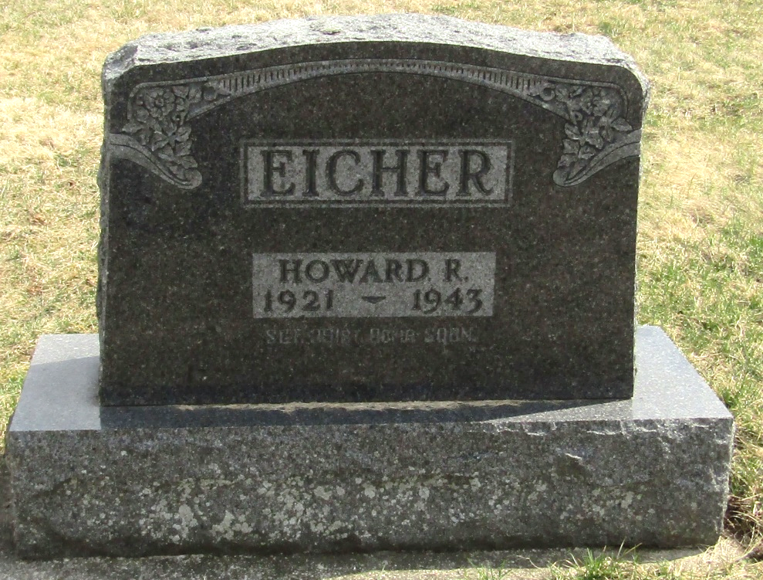
ADAMS COUNTY NATIVE DIES IN AIR CRASH
Howard Ray Eicher Is Bomber Victim
Funeral arrangements may be made late today for Staff Sgt. Howard Ray Eicher, 22, of Bluffton, and a native of Adams county, who died Wednesday in a bomber crash near Waldo, Kan.
No details concerning the crash were given in the message received by the victim's mother, Mrs. Dwight Bower at Bluffton, from his widow, now residing at Piqua, Ohio.
Sgt. Eicher was born in Hartford Township August 7, 1921, a son of Ray and Mabel Swagart-Eicher. He attended elementary schools in Adams County and was graduated from the Bluffton High School.
On August 23, 1942 he was married to Mildred Waltz of Bluffton. The following day he entered the army air forces.
The widow, parents, a brother, Pfc. Carl Eicher of Fort Sill, Okla., and the grandmother, Mrs. Jessie Swagart of Bluffton, survive.
The body is to be returned to Bluffton for funeral services and burial.

Decatur Daily Democrat, Adams County, Indiana
September 25, 1943

**
Handwritten date: Friday, September 24, 1948

SSG.HOWARD EICHER KILLED IN CRASH
Son of Ray Eicher Victim in Bomber Crash in Kansas

Staff Sergeant Howard R. Eicher, 22, was killed Wednesday in a bomber crash near Waldo, Kansas, according to word received by his wife at Piqua, Ohio, who forwarded meager information of the tragedy, to Eicher’s mother, Mrs. Dwight Bower at Bluffton. The ill-fated young airman was a son of Raymond Eicher, who is living with his father Chris Eicher at Geneva.
The bomber is said to have been on a routine test flight when it crashed but nothing has been learned as to the fate of the other members of the crew. S. Sgt. Eicher was a flight engineer with the Army Air Corps.
Sgt. Eicher was born in Hartford Township on August 7, 1921, a son of Raymond and Mable Swagart-Eicher. He attended elementary school in that township and graduated from Bluffton High School in 1939. On August 23, 1942, he was united in marriage to Miss Mildred Waltz, daughter of Mr. and Mrs. Roscoe Waltz, who have since moved to Piqua, Ohio. On the day following his marriage he entered service from Wells County in the Air Corps and had recently been stationed in Blythe, California.
He is survived by his wife, mother, father and a grandmother, Mrs. Jessie Swagart of Bluffton and a brother, Pfc. Carl Eicher, serving in the heavy artillery at Fort Sill, Oklahoma.

Adams County Historical Museum, Adams County, Indiana
January 1943 – July 1944 Scrapbook, image 10

**
Handwritten date: Friday, October 1, 1943

Body Still Held In Kansas

Word was received at Bluffton on Thursday that the body of Staff Sergeant Howard R. Eicher, 22, who was killed Wednesday, September 22, in the crash of an Army bomber near Waldo, Kans., still was held at Victoria Base, near the scene of the tragedy, with the information from the Red Cross field director at that point that the Army would not release the body until all victims of the crash had been identified.
It was added that it was expected that another day or two would elapse before the body was shipped and that the family would be notified at the time the body left Kansas and of its arrival here.

Adams County Indiana Historical Museum, Adams County, Indiana
January 1943 – July 1944 Scrapbook, image 12

