Earl Earhart
March 23, 1930 – March 7, 2012

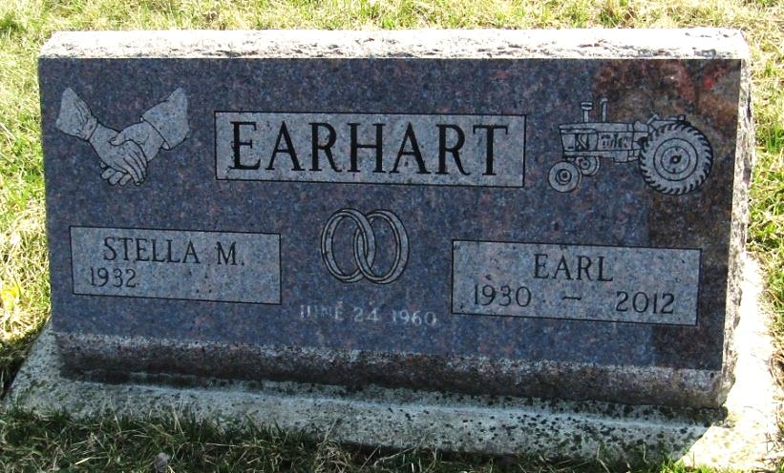
Earl Earhart, 81, of Montpelier, IN, passed away at 4:09 PM, on Wednesday, March 7, 2012 at Indiana University Health-Ball Memorial in Muncie, IN. He was born on Sunday, March 23, 1930, in Wells County, IN.
Earl retired from Sheller Globe in Montpelier after 47 years of service. He was a farmer, a member of the Friends of 5 Points School, had attended school in Wells County and enjoyed the outdoors and spending time in the woods.
He married Stella M. King on June 24, 1960 in Markle, Indiana. He was the son of the late Lawrence Earhart and the late Susan Dortha (Brinneman) Earhart.
Survivors include his Wife-Stella M. Earhart of Montpelier, Brother-Ernest (wife, Sue) Earhart of Muncie, Sisters-Alice Marie (husband, Bud) Walden of Liberty Center, Mary E. (husband, Dorsey) Price of Poneto, and several Nieces & Nephews. He was preceded in death by his Parents-Lawrence and Susan Dortha (Brinneman) Earhart and a Brother-Orva William Earhart.
Arrangements are being handled by Walker & Glancy Funeral Home, 109 West Windsor Street, Montpelier, Ind., where family and friends may gather to share and remember from 6:00 PM to 8:00 PM Saturday, March 10, 2012 and from 3:00 PM to 8:00 PM Sunday, March 11, 2012.
A service to celebrate his life will be at Walker & Glancy Funeral Home at 10:30 AM Monday, March 12, 2012 with the Les Bantz officiating. Burial will follow in the Stahl Cemetery in Wells County, IN.

Walker & Glancy Funeral Home
March 8, 2012

