George Dyson
October 9, 1839 – May 30, 1903

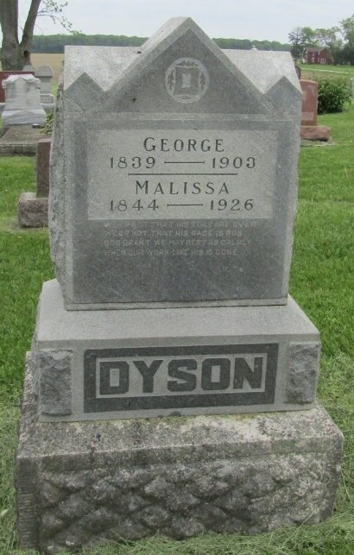
GEORGE DYSON DEAD

George Dyson, one of the prominent farmers of the county, living a mile south of Poneto, died Saturday night after a short illness. Mr. Dyson was about sixty-five years of age and has lived for many years on the home farm with his wife. His children are grown up.
The funeral occurred Tuesday at half past ten at the house with interment at the Stahl Cemetery. Mr. Dyson was a staunch Odd Fellow and the services were held under the auspices of that order.

Bluffton Banner, Wells County, Indiana
May 27, 1903

Indiana, Death Certificates, 1899-2011
Name: George Dyson
Gender: Male; Race: White; Age: 64; Marital status: Married
Birth Date: 1839; Birth Place: Hocking Co Ohio
Death Date: 30 May 1903; Death Place: Nottingham, Wells, Indiana
Father: ; Mother: ; Spouse: Cyntha Dyson
Informant: Chas. Dyson; Petroleum, Ind.
Burial: June 2, 1903; Stahl Cemetery

