Michael A. Duncan
April 24, 1952 – May 2, 2022

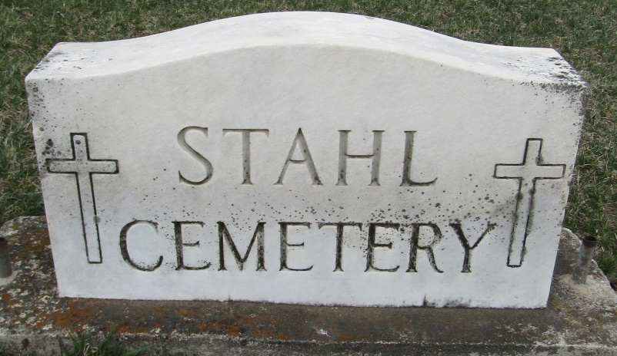

Michael A. Duncan, 70, passed away Monday, May 2, 2022, at Ossian Health and Rehabilitation Center in Ossian, IN. following an extended illness.
Mike was born in Bluffton, IN. on April 24, 1952, to George and Carol (Langel) Duncan, both parents preceded him in death. He married Shirley Mae (Pinkerton) in Bluffton on June 5, 1976, she survives in Bluffton.
He was a 1970 graduate of Norwell High School and attended Indiana University Business College, graduating with an Associate Degree. Mike was a United States Air Force veteran serving from 1972 to 1975. Mike was a lifelong member of the American Legion Post 111 in Bluffton and a member of the First Baptist Church.
He retired from Wabash Fiber Box-International Paper in 2017 after 39 years of service. Mike was also employed with Franklin Electric from 1976 to 1979. Mike enjoyed photography, traveling, tinkering and fixing anything that was broken, but most of all he enjoyed spending time with his grandchildren.
Survivors include his wife Shirley, a son; Chris (Stacey) Duncan of Bluffton, two daughters; April (Mark) Graves of Cincinnati, OH. and Julia (Dustin) Hiatt of Bluffton, three grandchildren; Jacob, Hailey, and Hannah Duncan, three brothers; Doug Duncan of Churubusco, IN, Thomas Duncan of Ft. Wayne and Ronald (Shari) Duncan of Bluffton, and a sister; Elizabeth “Liz” (Ron) Martin of Adams Lake, IN.
In addition to his parents, he was preceded in death by two sisters-in-law; Kaylene and Lisa Duncan.
Visitation will be Thursday, May 5, 2022, from 2:00 PM until 8:00 PM, at Goodwin – Cale & Harnish Memorial Chapel in Bluffton, and one hour prior to the service on Friday. A funeral service will be held at 11:00 AM on Friday, May 6, 2022, at the funeral home. Pastor Les Cantrell will officiate. Burial will follow at Stahl Cemetery in Bluffton, with military graveside rites conducted by the United States Air Force honor guard in conjunction with the American Legion Post 111 of Bluffton.
Memorials can be made to the American Legion Post 111 in Bluffton, IN.

Goodwin Funeral Homes, Wells County, Indiana
May 2, 2022

