Willie F. Dulworth
April 27, 1915 – November 9, 1962

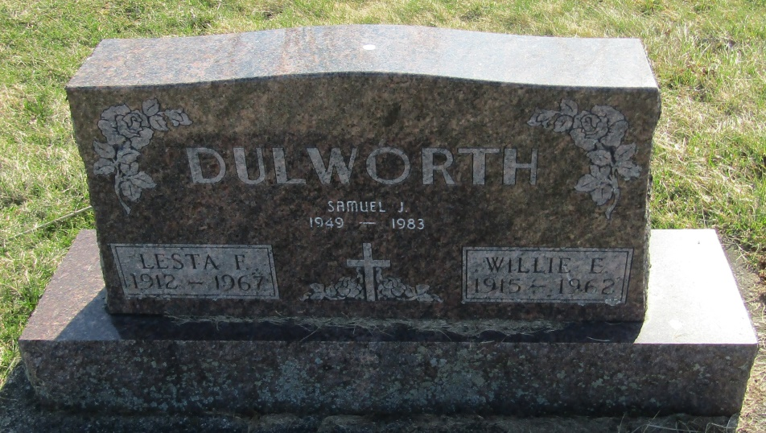

Willie Dulworth
in the Indiana, Death Certificates, 1899-2011
Name: Willie Dulworth
Gender: Male
Race: White
Age: 46
Marital status: Married
Birth Date: 27 Apr 1916
Birth Place: Tennessee
Death Date: 9 Nov 1962
Death Place: Bluffton, Wells, Indiana , USA
Father: Benjamin F Dulworth
Mother: Hexie Sullivan
Spouse: Lesta
Informant: Lesta Dulworth; wife; Petroleum, Ind.
Burial: Nov. 12, 1962; Stahl Cem., Wells Co., Ind.

