Thelma L. (Weakley) Dulinsky
May 5, 1916 – August 11, 1995

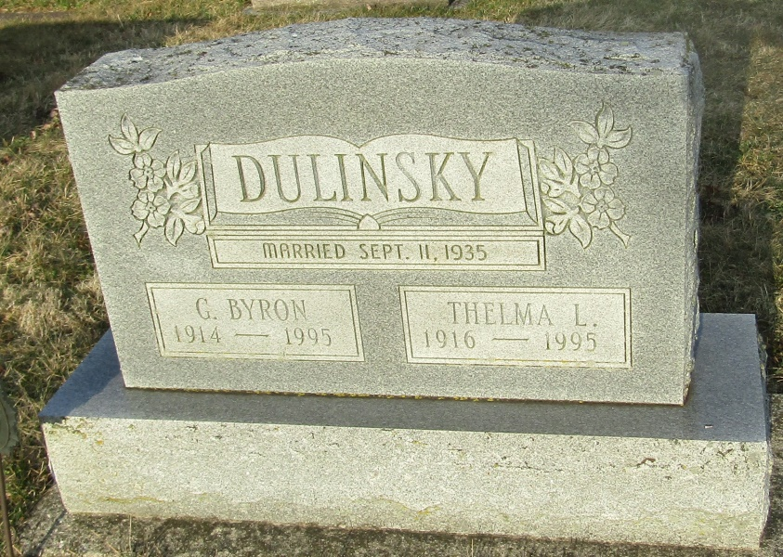

Thelma L Dulinsky
in the Indiana, Death Certificates, 1899-2011
Name: Thelma L Dulinsky
[Thelma L Weakley]
Gender: Female
Race: White
Age: 79
Marital status: Widowed
Birth Date: 5 May 1916
Birth Place: Wells County, In
Death Date: 11 Aug 1995
Death Place: Bluffton, Wells, Indiana , USA
Father: Charles Weakley
Mother: Pearl Douglas
Informant: Herbert Dulinsky; son; Wolcottville, Ind.
Burial: Aug. 14, 1995; Stahl Cem., Bluffton, Ind.

