Ruth Ellen (Yarger) Dulinsky
November 22, 1842 – July 4, 1943

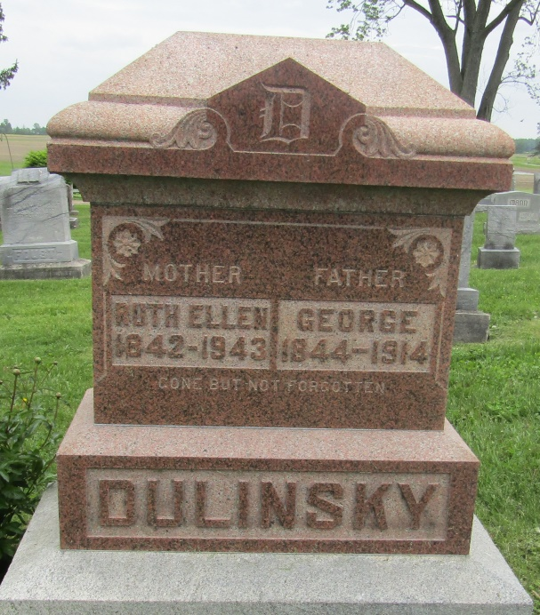

Ruth Ellen Dulinsky
in the Michigan, Death Records, 1867-1952
Name: Ruth Ellen Dulinsky
[Ruth Ellen Yarger]
Gender: Female
Race: White
Marital status: Widowed
Death Age: 100
Birth Date: 22 Nov 1842
Birth Place: Richland County, Ohio
Death Date: 4 Jul 1943
Death Place: Shelby, Oceana, Michigan, USA
Father: Joseph Yarger
Mother: Margaret Johnson
File Number: 004135
Informant: Mr. Bert Kelly; Shelby, Mich.
Removal: July 5, 1942; Bluffton, Ind.

