Mary M. (Taylor) Dickason
November 27, 1902 – September 2, 1998

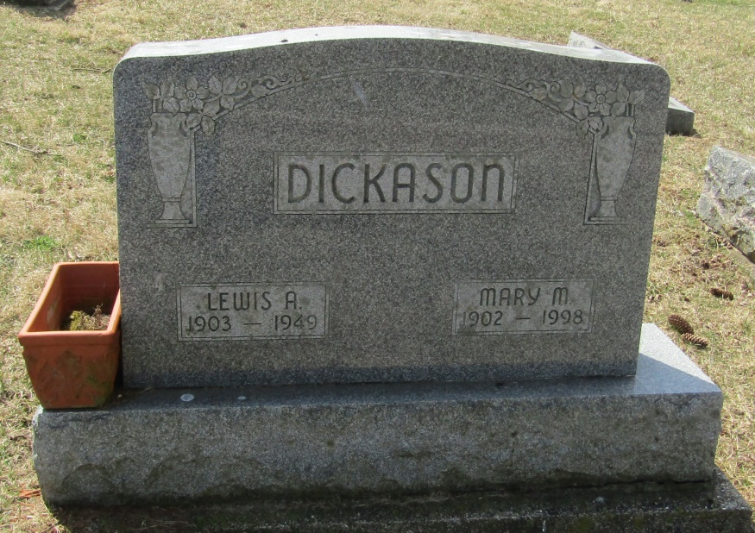

Mary M. Dickason
in the Indiana, Death Certificates, 1899-2011
Name: Mary M. Dickason
[Mary M. Taylor]
Gender: Female
Race: White
Age: 95
Marital status: Widowed
Birth Date: 27 Nov 1902
Birth Place: Jay County, In.
Death Date: 2 Sep 1998
Death Place: Keystone, Wells, Indiana , USA
Father: Charles Taylor
Mother: Ethel Havens
Informant: Jennifer Pursifull; granddaughter; Keystone, Ind.

