Jacob E. Dickason
August 2, 1835 – November 19, 1920

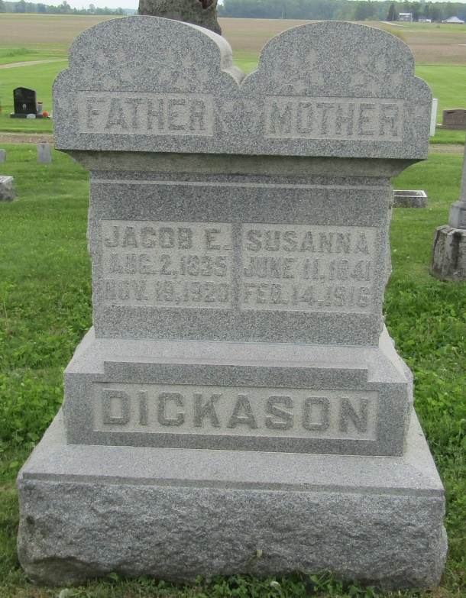
Jacob E Dickason
in the Indiana, Death Certificates, 1899-2011
Name: Jacob E Dickason
Gender: Male
Race: White
Age: 85
Marital status: Widowed
Birth Date: 2 Aug 1835
Birth Place: Ohio
Death Date: 19 Nov 1920
Death Place: Nottingham, Wells, Indiana , USA
Father: John Dickason
Mother: Nancy Stanley
Spouse: Susan Ifer
Informant: Family; Petroleum, Ind.
Burial: Nov. 21, 1920; Stahl Cem.

