George S. Dickason
November 15, 1861 – December 23, 1930

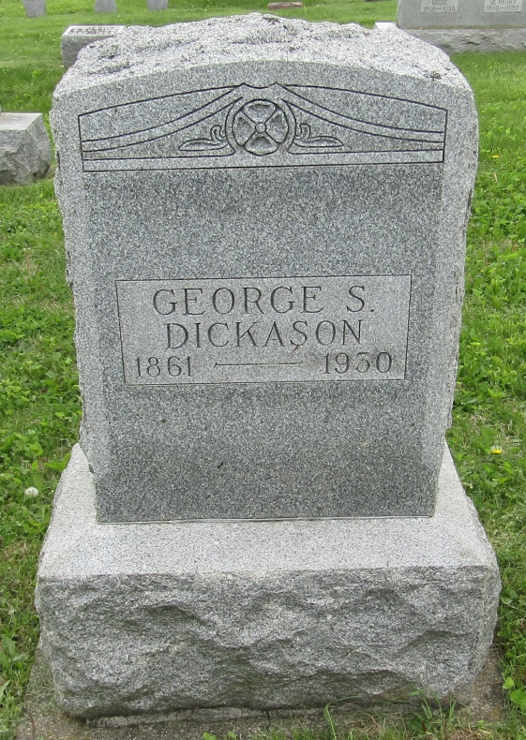

George Dickason
in the Indiana, Death Certificates, 1899-2011
Name: George Dickason
Gender: Male
Race: White
Age: 69
Marital status: Single
Birth Date: 15 Nov 1861
Birth Place: Nottingham Twp
Death Date: 23 Dec 1930
Death Place: Nottingham, Wells, Indiana , USA
Father: Jacob E Dickason
Mother: Susan Ifer
Informant: Dr. F. M. Dickason; Bluffton, Ind.
Burial: Dec. 26, 1930; Stahl Cem.

