Hiram Davis
March 24, 1868 – July 20, 1962

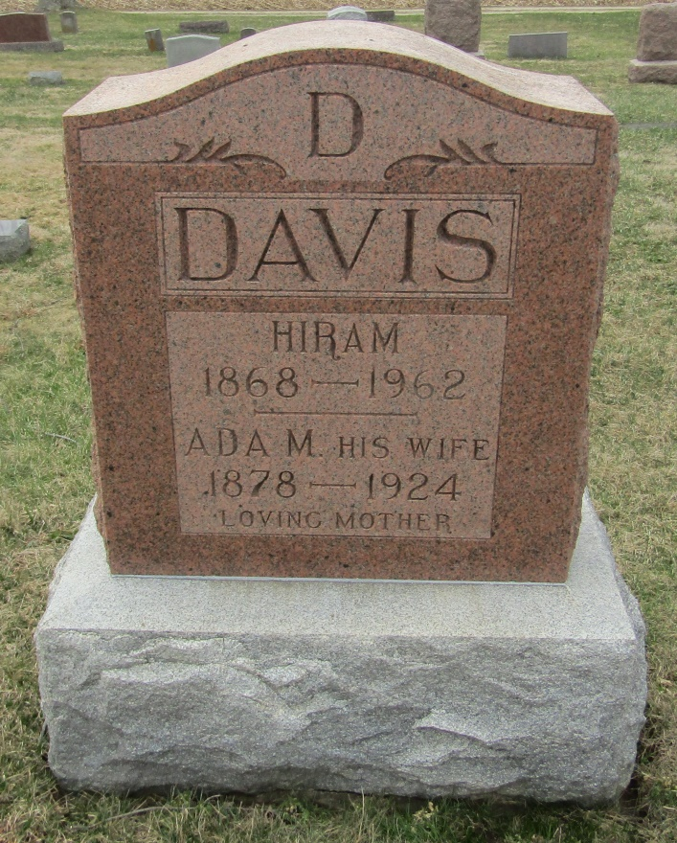
Hiram Davis
in the Indiana, Death Certificates, 1899-2011
Name: Hiram Davis
Gender: Male
Race: White
Age: 94
Marital status: Widowed
Birth Date: 24 Mar 1868
Birth Place: Ohio
Death Date: 20 Jul 1962
Death Place: Terre Haute, Vigo, Indiana , USA
Father: Henry Davis
Mother: Elizabeth Taylor
Informant: Vernon C. Davis; son; Terre Haute, Ind.
Burial: July 22, 1962; Stahl Cem., Bluffton, Ind.

