Scott A. Cowens
October 25, 1966 – February 9, 2016

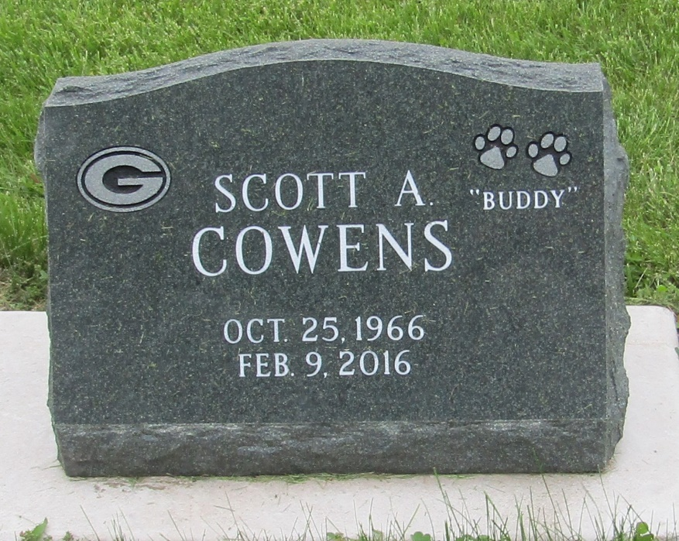

Scott A. Cowens 49 of Bluffton passed away on Tuesday afternoon, February 9, 2016, at his residence in Bluffton. Scott was born on October 25, 1966 in Bluffton to Charles R. Cowens & Sharon K. (Potter) Cowens. He graduated from Bluffton High School with the class of 1985. Scott was an avid Green Bay Packers fan and enjoying golfing with his family and friends. He worked at the Marriot in Fort Wayne and recently worked for Meijer in Indianapolis.
Scott is survived by his parents, Charles and Sharon of Bluffton along with two brothers Bob A. Cowens and Bill A. Cowens and a niece Emily K. Cowens all of Bluffton.
A Graveside service will be held at 2 p.m. on Wednesday (February 17, 2016) at Stahl Cemetery. Pastor Marlene Ellis will officiate.
Memorials may be made in Scott’s memory to Friends of the Shelter of Wells County. Funeral arrangements have been entrusted to the care of the Thoma/Rich, Lemler Funeral Home in Bluffton.

Thoma/Rich Funeral Home, Wells County, Indiana
February 10, 2016

