Isaac Johnson Brittenham
February 2, 1838 – September 3, 1913

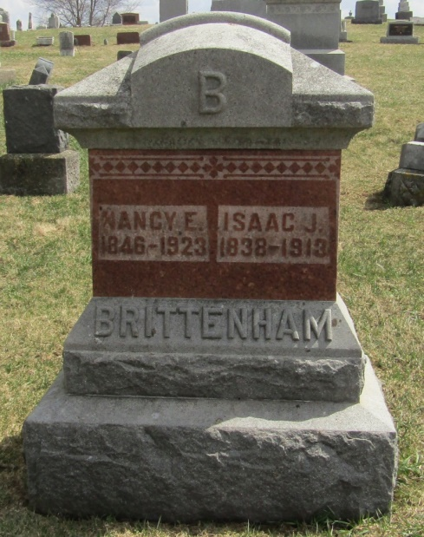

Isaac Johnson Brittenham
in the Indiana, Death Certificates, 1899-2011
Name: Isaac Johnson Brittenham
Gender: Male
Race: White
Age: 76
Marital status: Married
Birth Date: 2 Feb 1837
Birth Place: Ohio
Death Date: 3 Sep 1913
Death Place: Nottingham, Wells, Indiana, USA
Father: Aaron Brittenham
Mother: Margret Carmean
Spouse: Nancy Dudley
Informant: Family; Poneto, Ind.
Burial: Sept. 4, 1913; Stahl Cem.

