Gerald Vaughn Bower
December 25, 1904 – November 21, 1970

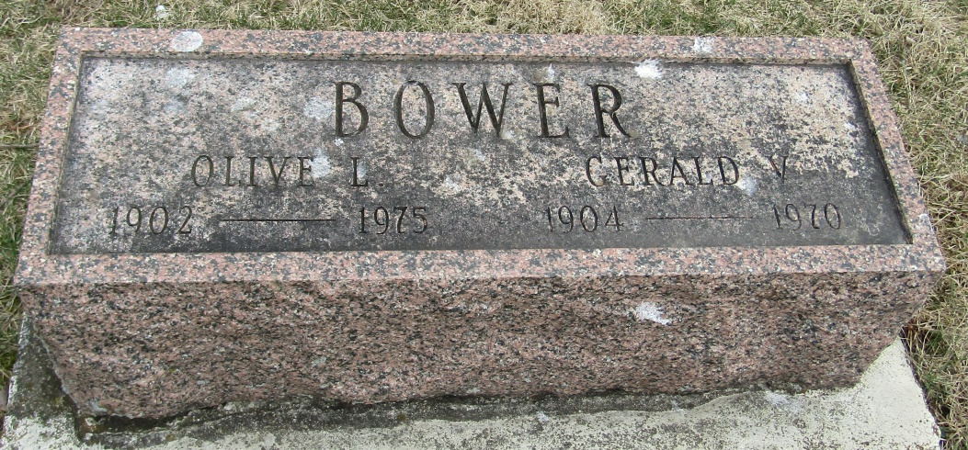
Gerald Vaughn Bower, 65, of Geneva, Indiana died suddenly Saturday P.M. of a heart attack while cutting lumber east of Decatur. A native of Wells County, he was born December 25, 1904, a son of Mahlon and Anna May Bower. He was married to Olive Onweller, who survives.
Also surviving are four daughters, Mrs. Pauline Ineichen of Geneva, Mrs. Margaret Brown of Portland, Mrs. Marjorie Elgin of Bluffton and Mrs. Mabeline Barcus of Pennville; two sons, Elmer of Bluffton and Everett of Pennville; a brother, Dwight of Bluffton, 19 grandchildren and 13 great-grandchildren.
Services will be held Tuesday at Hardy & Hardy Funeral Home at Geneva; Rev. Ray Bachman will officiate and burial will be in Stahl Cemetery.

Wells County, Indiana Obituaries
November 21, 1970
*****
Indiana, Death Certificates, 1899-2011
Name: Gerald Vaughn Bower
Race: White
Age: 65
Marital status: Married
Birth Date: 25 Dec 1904
Birth Place: Indiana
Death Date: 21 Nov 1970
Death Place: Decatur, Adams, Indiana , USA
Father: Mahion Bower
Mother: Anna May
Spouse: Olive Bower
Informant: Mrs. Gerald Bower; wife; Geneva, Ind.
Burial: Nov. 24, 1970; Stahl Cem., Petroleum, Ind.

