George E. Bower
August 20, 1937 - July 22, 2010

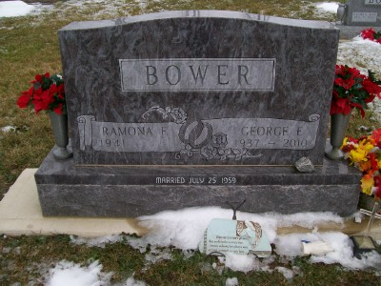
Photo by Scott Shoup

George E. Bower, 72, of Poneto, died at 1:29 a.m. Thursday, July 22, 2010, at his residence.
Mr. Bower was born in Poneto on Aug. 20, 1937, to Paul V. and Florence (Cline) Bower. He married Ramona Carr in Bluffton on July 25, 1959; she survives.
A 1955 graduate of Petroleum High School, Mr. Bower retired from Franklin Electric in 2000 after 44 years service. He was also involved with farming during that time, and served in the Army National Guard of Indiana. Other surviving relatives include one son, David (Kemberley) Bower of Poneto; two sisters, Linda (Jimbob) Ogle of Poneto and Judy (Franklin J.) Heavin-Schwegman of New Castle, Ind.; and seven grandchildren, Kyle, Krystal, Trevor, Kasey, Derick, Jordan and Matthew.
Mr. Bower was preceded in death by one sister, Lavelle Nierman; and three brothers, Mahlon, Marvin and Paul L. Bower.
Calling hours will be from 3 to 8 p.m. Saturday, July 24, at the Goodwin Memorial Chapel in Bluffton. A private family graveside service will be held at Stahl Cemetery at a later date with Pastor Roy Nevil officiating. American Legion Post 111 will perform military graveside rites.
Preferred memorials are to the Poneto United Methodist Church.
Online condolences:www.thegmcfamily.com.
Bluffton News-Banner, The (Wells County, IN)
Friday, July 23, 2010
Contributed by Jane Edson

