Dwight L. Moody Bower
December 7, 1902 – January 29, 1977

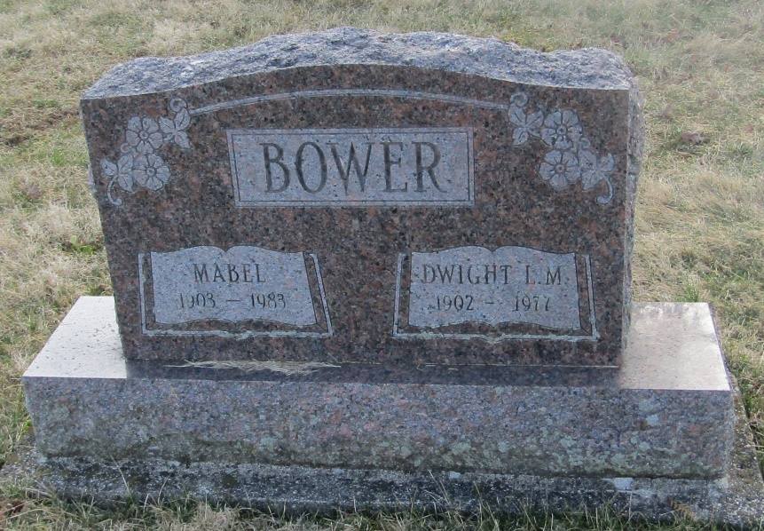

Dwight L. Moody Bower
in the Indiana, Death Certificates, 1899-2011
Name: Dwight L. Moody Bower
Gender: Male
Race: White
Age: 74
Marital status: Married
Birth Date: 7 Dec 1902
Birth Place: Indiana
Death Date: 29 Jan 1977
Death Place: Bluffton, Wells, Indiana , USA
Father: Mahlon Bower
Mother: Urna May Rush
Spouse: Mabel Swagart
Informant: Mrs. Dwight Bower; wife; Bluffton, Ind.
Burial: Feb. 1, 1977; Stahl Cem., Wells Co., Ind.

