Ralph J. Blair
December 9, 1909 – November 8, 1910

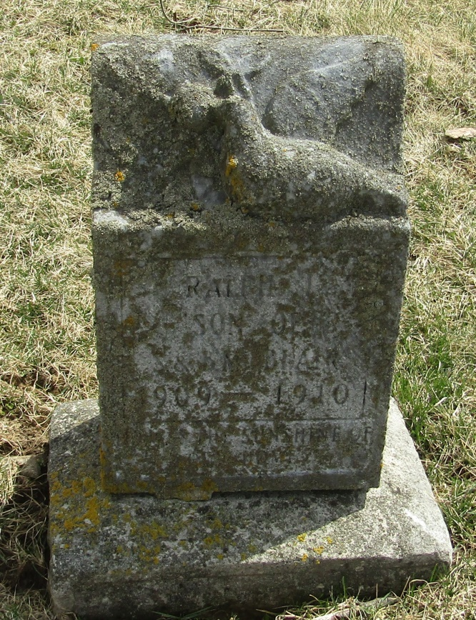
Ralple J. Blair
in the Indiana, Death Certificates, 1899-2011
Name: Ralph J. Blair
Gender: Male; Race: White; Age: 10/12; Marital status: Single
Birth Date: 9 Dec 1909; Birth Place: Wells Co Ind
Death Date: 8 Nov 1910; Death Place: Nottingham, Wells, Indiana
Father: Samuel Blair; Mother: Bertha Holloway
Burial: Nov. 9, 1910; Stahl Cem.

