Charlie Allen
June 18, 1937 – March 14, 1993

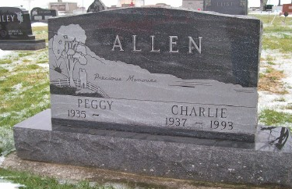
Photo by Scott Shoup

BLUFFTON - Charlie Allen, 55. Services at 1:30 p.m. Tuesday in the Goodwin Memorial Chapel, Bluffton. Calling from 6-9 p.m. today.

Decatur Daily Democrat, Adams County, Indiana
March 15, 1993
*****

Indiana, Death Certificates, 1899-2011
Name: Charlie Allen
Gender: Male
Race: Black
Age: 55
Marital status: Married
Birth Date: 18 Jun 1937
Birth Place: Roll MS
Death Date: 14 Mar 1993
Death Place: Bluffton, Wells, Indiana , USA
Father: Mock Allen
Mother: Adelio ?
Spouse: Peggy McKenzie
Informant: Peggy Allen; wife; Poneto, Ind.
Burial: March 16, 1993; Stahl Cem., Reifsburg, Ind.

