Cebirt H. Abshire
May 6, 1874 – February 17, 1890

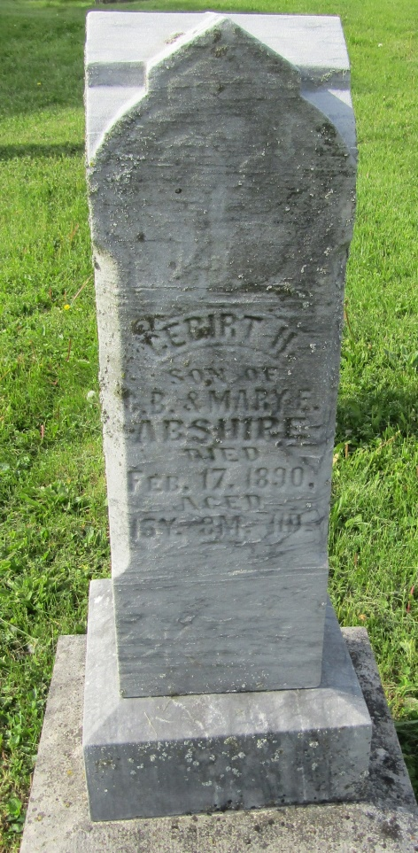
Indiana, WPA Death Index, 1882-1920
Name: C. B. Abshiro
Date: 18 Feb 1890
Location: Wells County
Age: 13 Yr
Gender: Male
Race: White
Source location: County Health Office, Bluffton
Source Notes: The source of this record is the book H-14 on page 18 within the series produced by the Indiana Works Progress Administration.

