Hiram Schoonover
1842 – January 26, 1920

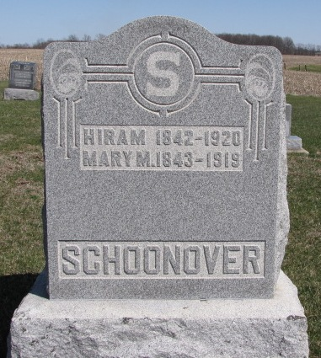
Photo by Barbara Baker Anderson

SCHOONOVER

Bluffton, Ind., Jan. 26 – Hiram Schoonover, 78, a resident of Union Township, this county, most of his life dropped dead at 8:30 o’clock this morning while he was eating breakfast at the home of his son, Ambrose Schoonover at Uniondale.
Death was ascribed to an attack of heart disease.
A brother, William, resides at Argon, Ind.
Funeral services will be held at the Lutheran church at Uniondale, at 1:30 o’clock Wednesday afternoon and burial will be at the St. John’s Cemetery in Union Township.

Journal-Gazette, Fort Wayne, IN; January 27, 1920, Page 14

Contributed by Jim Cox

