Sarah Elizabeth (Owen) Vickrey
November 18, 1860 – November 23, 1900

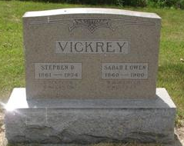
Photo by Sarge

Sarah Elizabeth Vickeny
in the Indiana, Death Certificates, 1899-2011
Name: Sarah Elizabeth Vickeny
[Sarah Elizabeth Owen]
Gender: Female
Race: Wht
Age: 40 years, 5 days
Marital status: Married
Birth Date: abt 1860
Birth Place: Indiana
Death Date: 23 Nov 1900
Death Place: Liberty, Wells, Indiana, USA
Father: Jessie K Owen
Mother: Liberta Witty
Informant: Harry Deane?
Burial: November 25, 1900; Green ?? Cemetery; Wabash County, Indiana (sic)

