Dorothy Vickrey
March 11, 1909 – March 17, 1909

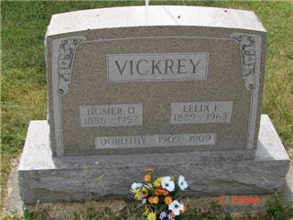
Photo by Sarge

Dorothy Vickery
in the Indiana, Death Certificates, 1899-2011
Name: Dorothy Vickery
Gender: Female
Race: White
Age: 6 days
Birth Date: 11 Mar 1909
Birth Place: Huntington Co
Death Date: 17 Mar 1909
Death Place: Rockcreek, Huntington, Indiana, USA
Father: Homer Vickery
Mother: Lela Bull
Burial: March 18, 1909; Spider Hill Cemetery

