Samuel Stanton
1875 – September 6, 1876

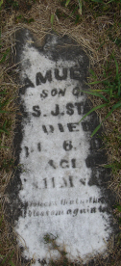
Photo by Sarge

No further information found at this time

