Riley Stanton
August 7, 1829 – July 12, 1900

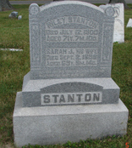
Photo by Sarge

Riley Stauton
in the Indiana, Death Certificates, 1899-2011
Name: Riley Stanton
Gender: Male
Race: White
Age: 71 years, 7 months, 10 days
Birth Date: abt 1829
Birth Place: NC
Death Date: 12 Jul 1900
Death Place: Rock Creek, Huntington, Indiana, USA
Father: John Stanton
Mother: Elizabeth Swain
Informant: Delphina Sheets; Rock Creek Township
Burial: July 14, 1900; Barbers Mill Cemetery

