Mary Catherine (Cowen) Stahl
April 1, 1836 – September 27, 1909

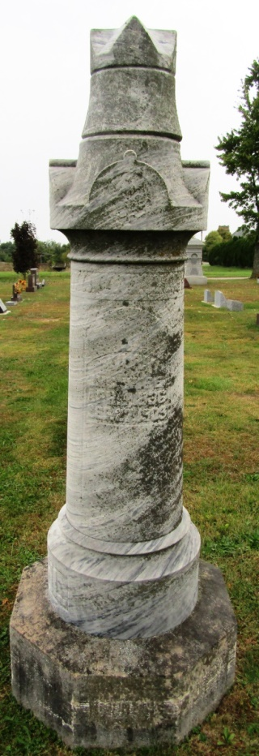

Mury Catherine Stall
in the Indiana, Death Certificates, 1899-2011
Name: Mary Catherine Stall
[Mury Catherine Cowen]
Gender: Female
Race: White
Age: 73
Marital status: Married
Birth Date: 1 Apr 1836
Birth Place: Ohio
Death Date: 27 Sep 1909
Death Place: Wabash, Adams, Indiana, USA
Father: Henry Cowen
Informant: David Stall; Lafayette, Indiana
Burial: September 29, 1909; Rockford Cemetery

