Lela A. (McBride) Sheets
1896 - 1973

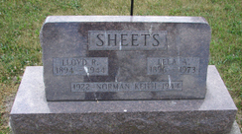
Photo by Sarge

No further information found at this time

