Martha Jane (Redding) Seigman
May 25, 1854 – February 22, 1930

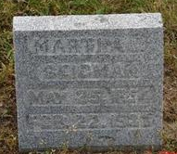
Photo by Sarge

Martha Jane Seigman
in the Indiana, Death Certificates, 1899-2011
Name: Martha Jane Seigman
[Martha Jane Redding]
Gender: Female
Race: White
Age: 76
Marital status: Widowed
Birth Date: 17 Jan 1854
Birth Place: N.C.
Death Date: 22 Feb 1930
Death Place: Rock Creek, Huntington, Indiana , USA
Father: T.W. Redding
Mother: Clarissa Walker?
Spouse: Louis Seigman; deceased
Informant: T. W. Redding; Muncie, Indiana
Burial: February 25, 1930; M.E. Cemetery; Rockford, Indiana

