Verta M. (Harrison) Sale
December 29, 1889 – July 26, 1960

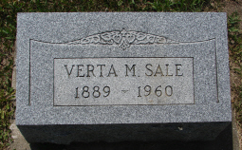
Photo by Sarge

Verta M Sale
in the Indiana, Death Certificates, 1899-2011
Name: Verta M Sale
[Verta M Harrison]
Gender: Female
Race: White
Age: 70
Marital status: Widowed
Birth Date: 29 Dec 1889
Birth Place: Indiana
Death Date: 26 Jul 1960
Death Place: Ft Wayne, Allen, Indiana, USA
Father: Charles Harrison
Mother: Alice C Cheney
Informant: Mrs. Russell Burns; daughter; Fort Wayne, Indiana
Burial: July 28, 1960; Spider Hill Cemetery; Rockford, Indiana

