Sarah Delpha Angeline (Redding) Sale
April 12, 1844 – July 17, 1922

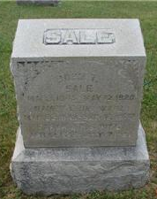
Photo by Sarge

Sarah Delpha Angeline Sale
in the Indiana, Death Certificates, 1899-2011
Name: Sarah Delpha Angeline Sale
[Sarah Delpha Angeline Redding]
Gender: Female
Race: White
Age: 78
Marital status: Widow
Birth Date: 12 Apr 1844
Birth Place: Urlks Co W. Carolina
Death Date: 17 Jul 1922
Death Place: Bluffton, Wells, Indiana, USA
Father: Morten Redding
Mother: Sarah Martin
Spouse: John R Sale
Informant: Family; Bluffton, Indiana
Burial: July 19, 1922; Rockford Cemetery; Wells County, Indiana

